General Workflow (may vary by team)
- Look at the schedule to see if the patient has MyChart Activated or Not- this determine where the link is originating from and whether the patient needs to complete the MyChart E check in process or not.
- Select the patient up to 20 min prior to the appointment time, to see if the patient is green in CIS
- If the patient is not green in CIS please call the patient and look to Tips below on how to assist the patient in logging into the video visit prior to the provider appointment time.

MyChart Tips
When navigating MyChart they will need to ensure the patient logs into MyChart (create a password, if pending activation)
1. Log in to your MyChart account by opening a web browser and go to https://mychart.seattlechildrens.org.
2. Click the Appointments icon at the top of the screen. Find your scheduled video visit and click eCheck-In. Your appointment cannot begin before you complete eCheck-In.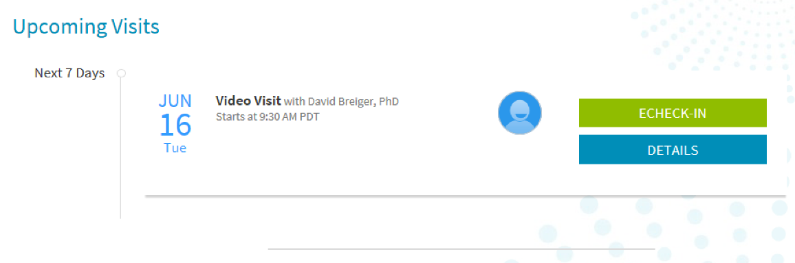
3. Click eCheck-in. The patient will need to validate Personal info, Insurance and sign any consent forms to complete the eCheck-in process. Medication, allergies and health issues are not active until Oct 3rd.
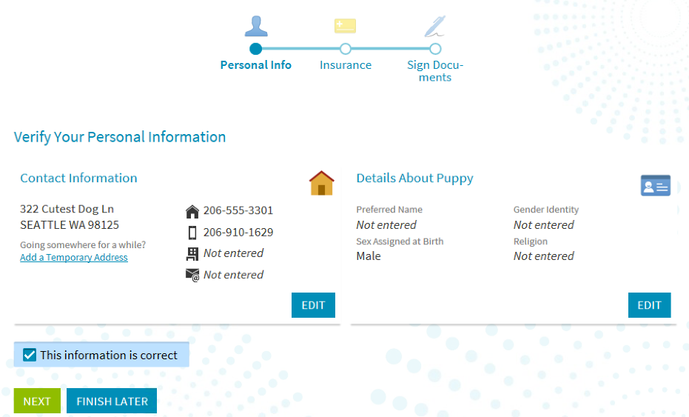
The patient will need to check the box confirming the information is correct. Then click Next to move to the next window.
Once the eCheck-in process is complete, they will need to click Submit.
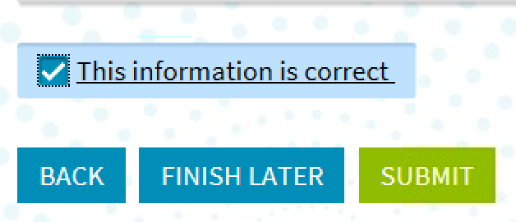
4. Once eCheck-In is complete, click Begin Video Visit.
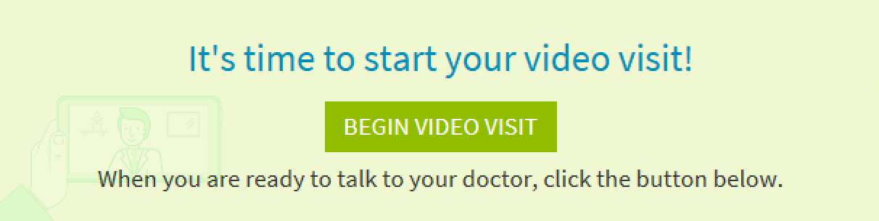

Zoom Tips
When the MA initiates the video visit before the provider starts the visit, please ensure the patient is on the line.
At this time, you can add an interpreter prior to the start of the visit.
If patient is not in the waiting room, please call the patient to see if they have joined Zoom.

Troubleshooting why the patient is not in the zoom visit

Pop-Up Blockers
Ensure the patient turns off all pop-up blockers
Mobile Device
Go into Settings
Select Browser icon (Safari etc.)
Remove “pop-up blockers”

Patient on phone saying they are in zoom but not visible to the MA
Select the meeting information “i” icon and read the number of the meeting ID to the patient so they can log out of the current visit and into the correct visit

The patient will connect to the visit and the visit can begin.

Additional items
If the visit needs to be placed on hold, click More in the Participants window and select Put in waiting room.
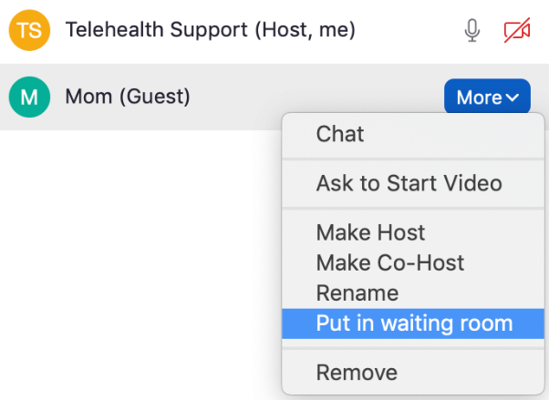
The patient will appear as waiting. Click Admit to have them rejoin the visit.
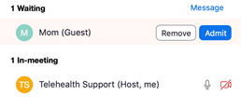
If for any reason a participant must be kicked out of a session, the host should click More in the Participants window and select Remove.
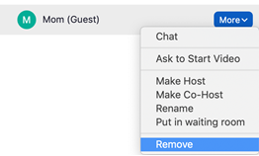

If a provider is the active host and must leave, he/she can transfer the host to another provider or other clinical staff in the session. Click More in the Participants window and select Make Host.
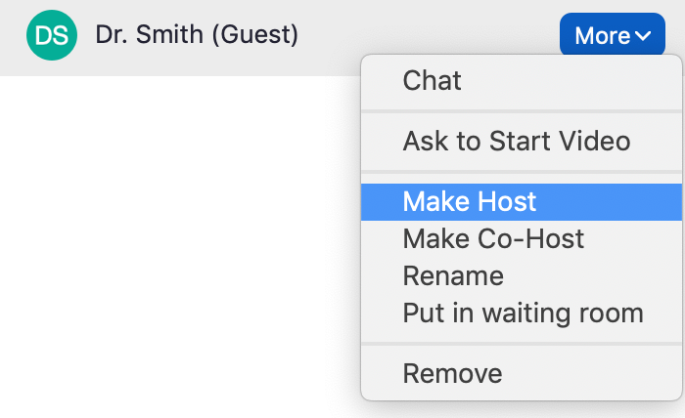

How to leave the meeting
Then click on End and select Leave Meeting
